
NAGONGERA CAMPUS
FACULTY OF SCIENCE AND EDUCATION
DEPARTMENT OF COMPUTER STUDIES

COURSE UNIT: DATABASE MANAGEMENT SYSTEMS
COURSE CODE: BIT 3101
STUDENT: KITARA OKELLO EMMANUEL
REG NO: BU/UP/2023/1495
LECTURER: DR. ANGOLE RICHARD

Case Scenario
KIU is a private university with several units like registry which handles student affairs. The followings are the faculties under registry: psychology, business, education, technical. Departments under education include: counseling, physics, chemistry, biology; under business include: BAM, MBA, CS, BIT, MCHD, EDU; under technical education include: wood work, metal, art and design; psychology include: general psychology, medical psychology, community psychology; under counseling include: social, family, community, individual counseling. You are hired by Academic Registrar to develop, MYSQL database to manage student information. Use this information to accomplish the given task. Other necessary information may include: student registration number, telephone, year of study.
- Create a database give it a name with extension KIU.
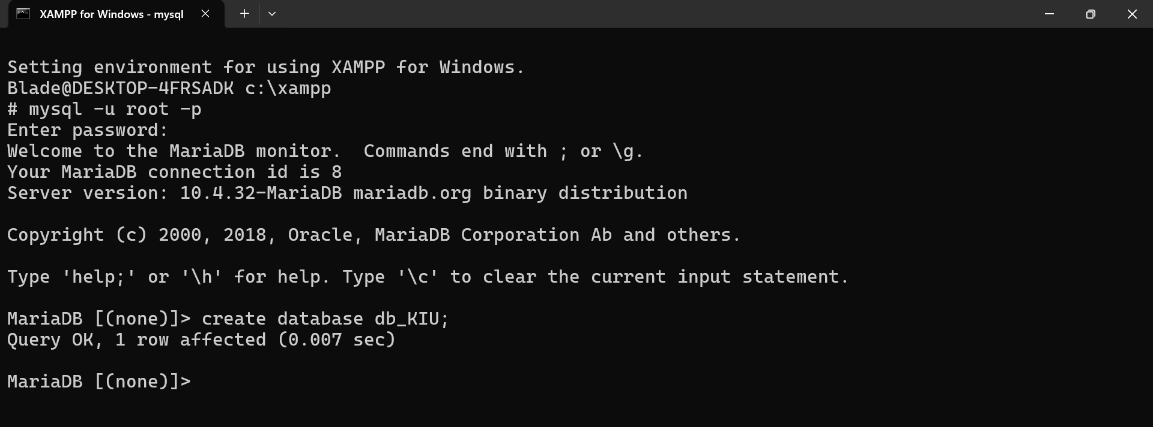
- Check if your database exists among others
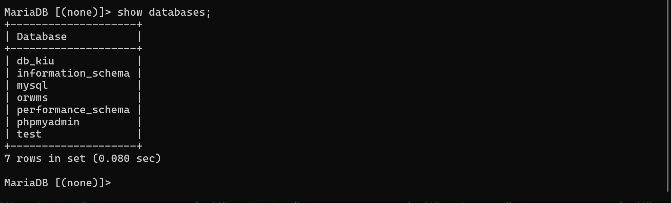
- Create table ‘student’ that contains relevant fields
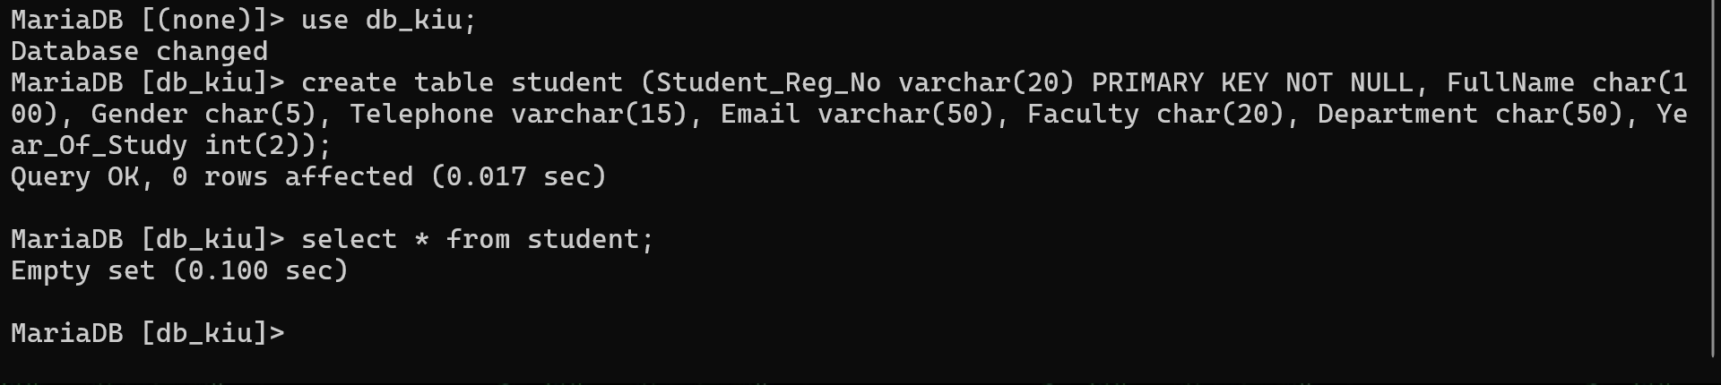
- Populate table with at least 15 rows but with four students from BAM.
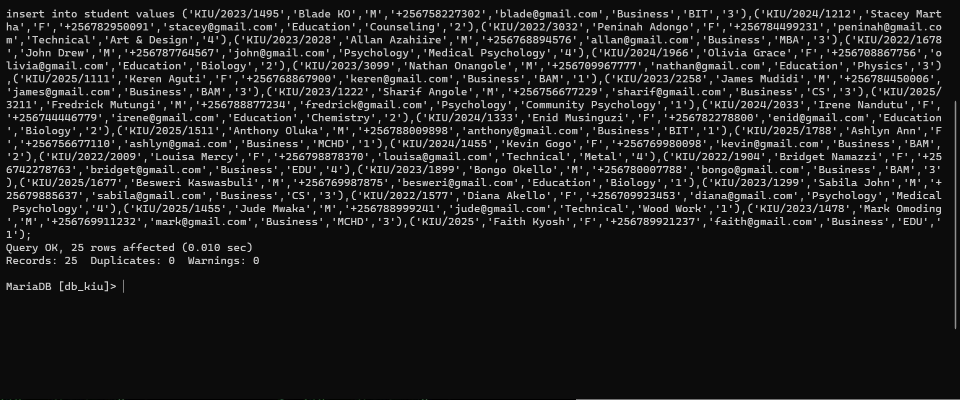
- Delete two students from BAM
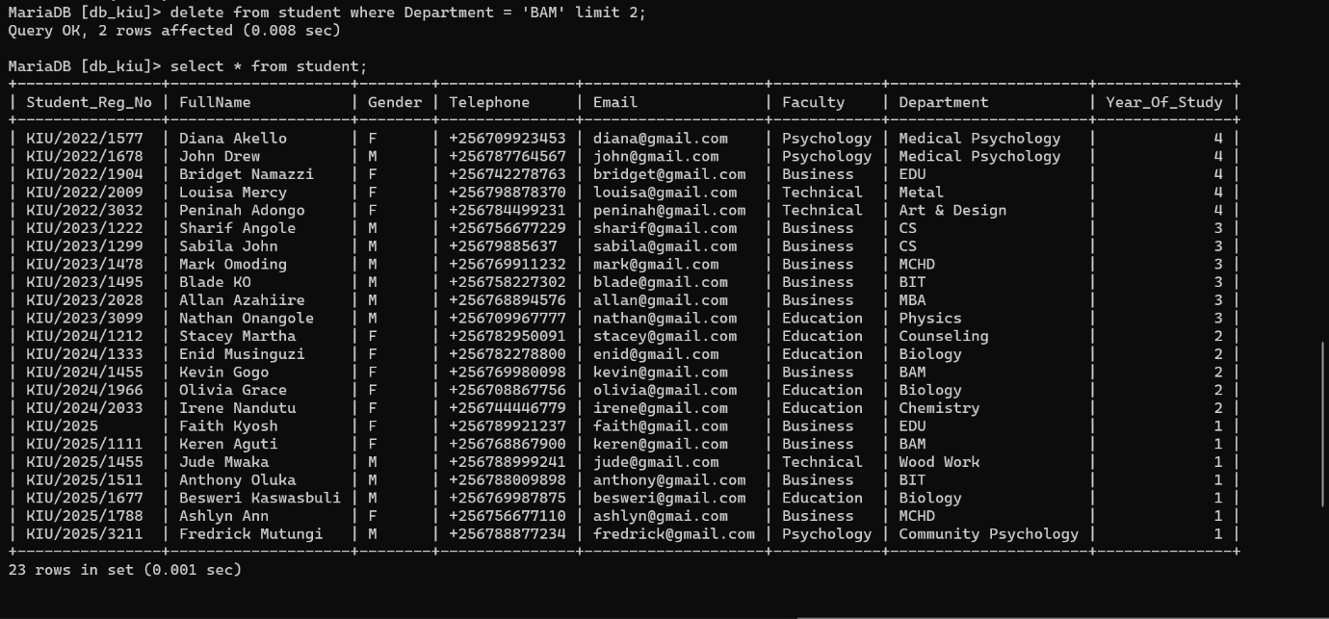
- Find how many students do computer studies (CS) and are in year one.
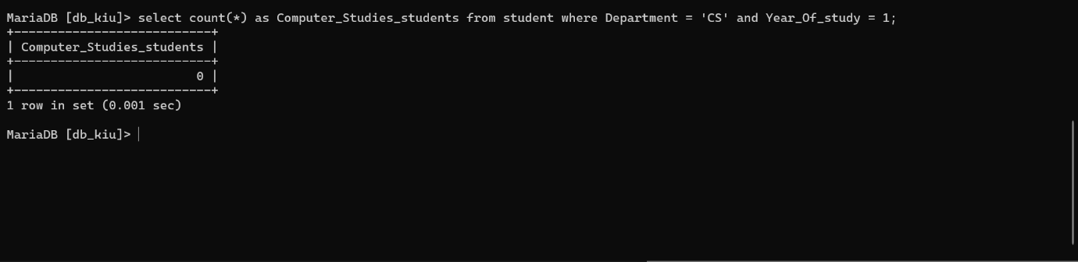

- Find students doing MCHD whose names start with letter A
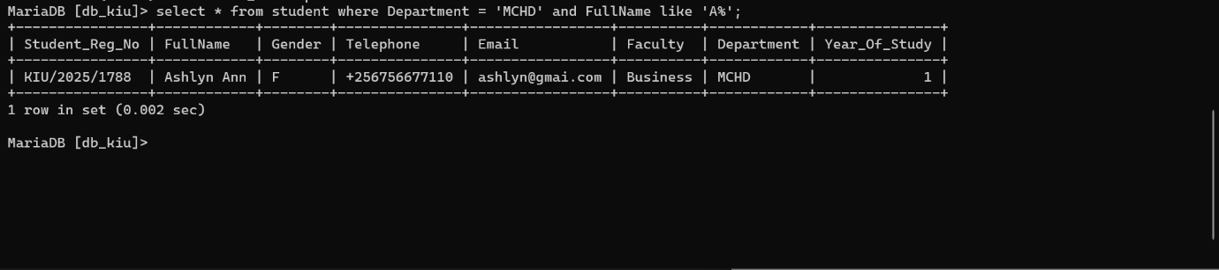
- Find any student doing EDU
